RANDOM SAMPLING AND SAMPLING DISTRIBUTION

AIM
To explore random sampling from a population and to understand the concept of sampling distribution (and the Central Limit Theorem) using Python.

PROGRAM
import numpy as np
import matplotlib.pyplot as plt

np.random.seed(42)

# Step 1: Generate a population (normal distribution)
population_mean = 50
population_std = 10
population_size = 100000
population = np.random.normal(population_mean, population_std, population_size)
print("Population mean :", round(np.mean(population), 3))
print("Population std :", round(np.std(population), 3))

# Step 2: Random sampling
sample_sizes = [30, 50, 100] # different sample sizes to consider
num_samples = 1000 # number of samples for each sample size

sample_means = {}
for size in sample_sizes:
sample_means[size] = []
for _ in range(num_samples):
sample = np.random.choice(population, size=size, replace=False)
sample_means[size].append(np.mean(sample))

print("\nSize Mean(sample means) Std(sample means) Theoretical SE")
for size in sample_sizes:
m = np.mean(sample_means[size])
sd = np.std(sample_means[size])
se = population_std / np.sqrt(size)
print(f"{size:<6}{m:<20.3f}{sd:<19.3f}{se:.3f}")

# Step 3: Plotting sampling distributions
plt.figure(figsize=(12, 8))
for i, size in enumerate(sample_sizes):
plt.subplot(len(sample_sizes), 1, i + 1)
plt.hist(sample_means[size], bins=30, alpha=0.7, label=f'Sample Size {size}')
plt.axvline(np.mean(population), color='red', linestyle='dashed',
linewidth=1.5, label='Population Mean')
plt.title(f'Sampling Distribution (Sample Size {size})')
plt.xlabel('Sample Mean')
plt.ylabel('Frequency')
plt.legend()
plt.tight_layout()
plt.show()

# Step 4: Central Limit Theorem with a skewed (exponential) population
skewed = np.random.exponential(scale=10, size=population_size)
plt.figure(figsize=(14, 3.5))
plt.subplot(1, 4, 1)
plt.hist(skewed, bins=50, color='grey')
plt.title('Exponential population')
for i, size in enumerate([2, 30, 100]):
means = [np.mean(np.random.choice(skewed, size=size, replace=False))
for _ in range(num_samples)]
plt.subplot(1, 4, i + 2)
plt.hist(means, bins=30)
plt.title(f'Sample means (n={size})')
plt.tight_layout()
plt.show()

OUTPUT
Population mean : 50.01
Population std : 10.009

Size Mean(sample means) Std(sample means) Theoretical SE
30 49.981 1.856 1.826
50 49.957 1.490 1.414
100 50.024 1.000 1.000

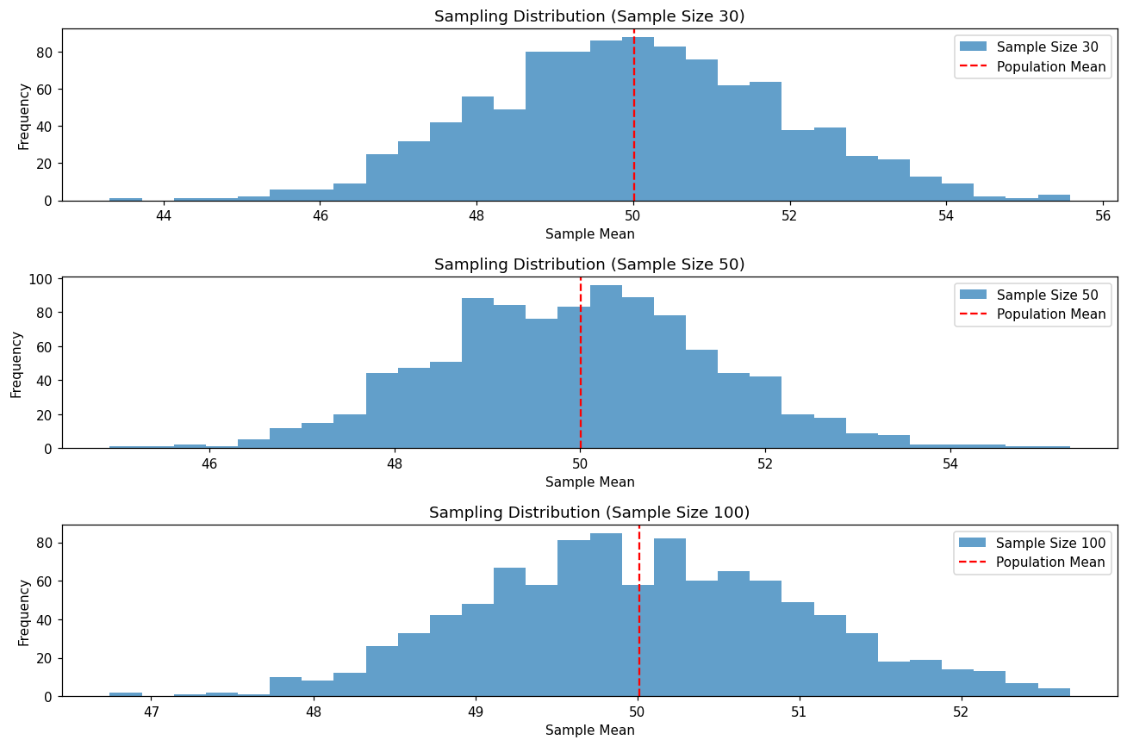
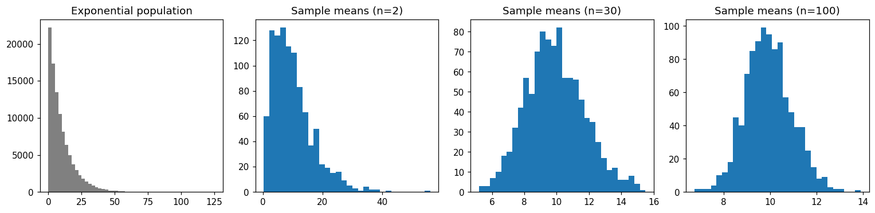

RESULT
Thus random samples were drawn from a population and the sampling distribution of the sample mean was plotted. The mean of the sample means is close to the population mean, the spread shrinks as the sample size increases, and the Central Limit Theorem was verified.

